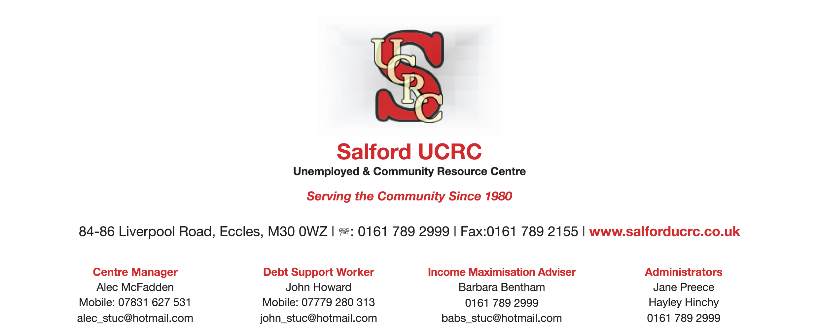

Dr Gilani
Monton Medical Centre
Canal Side
Monton
M30 8AR

Our Ref 220450

1 September 2010

Press Release 30/09/16 Following the Successful press campaign in August in relation to illegal benefit sanctions, This new press release is related to disabled and sick / ill people.

A record number of 18 injured and disabled clients came into the Salford Unemployed & Community Resource Centre in September where each and every one had been awarded nil points at either their work capability assessment ‘’fit to work’’ tests or face to face consultation for PIP. This means they are deemed fit to work or not entitled to disability benefits.
Yesterday 4 clients (one of whom is an amputee) came into the centre seeking advice and assistance; as 3 had failed their work capability assessment and the other their face to face consultation with a zero score.
Alec McFadden Centre Manager Said ‘’The Government appointed private companies to carry out these assessments and the number of disabled people found fit for work is ridiculous. The companies are Maximus, Capita & Atos. These are profit making companies that make money out of this work and create misery for so many disabled people. Eventually we win the appeals and all the payments are paid back to our clients, so no money is actually made. The SUCRC will carry out the appeal without any charge. ‘’
Any ill or disabled person in Salford who has recently been in this situation should contact the centre for free advice and representation on 0161 789 2999.
All Local members of Parliament have been alerted.
The number of cases spread across our local members of Parliament are:
Barbara Keeley MP – 10 cases
Rebecca Long Bailey MP – 5 cases
Graham Stringer MP – 2 cases
Gerald Kaufman MP – 1 case

Alec McFadden

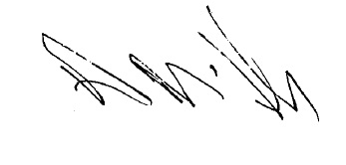
Centre Manager
Tel: 0161 789 2999
Mob: 07831 627531

